Ideation phase

Empathize & discovery

|  |  |
| --- | --- |
| Date | 22 June 2025 |
| Team Id | LTVIP2025TMID50687 |
| Project Name | visualizing housing market trends: an analysis of sale prices and features using tableau |
| Maximum Marks | 4 Marks |

Empathy Map Canvas:

An empathy map is a simple,easy-to-digest visual that captures knowledge about a users’s behaviours and attitudes

It is a useful tool to helps teams better understand their users.

Empathy Map

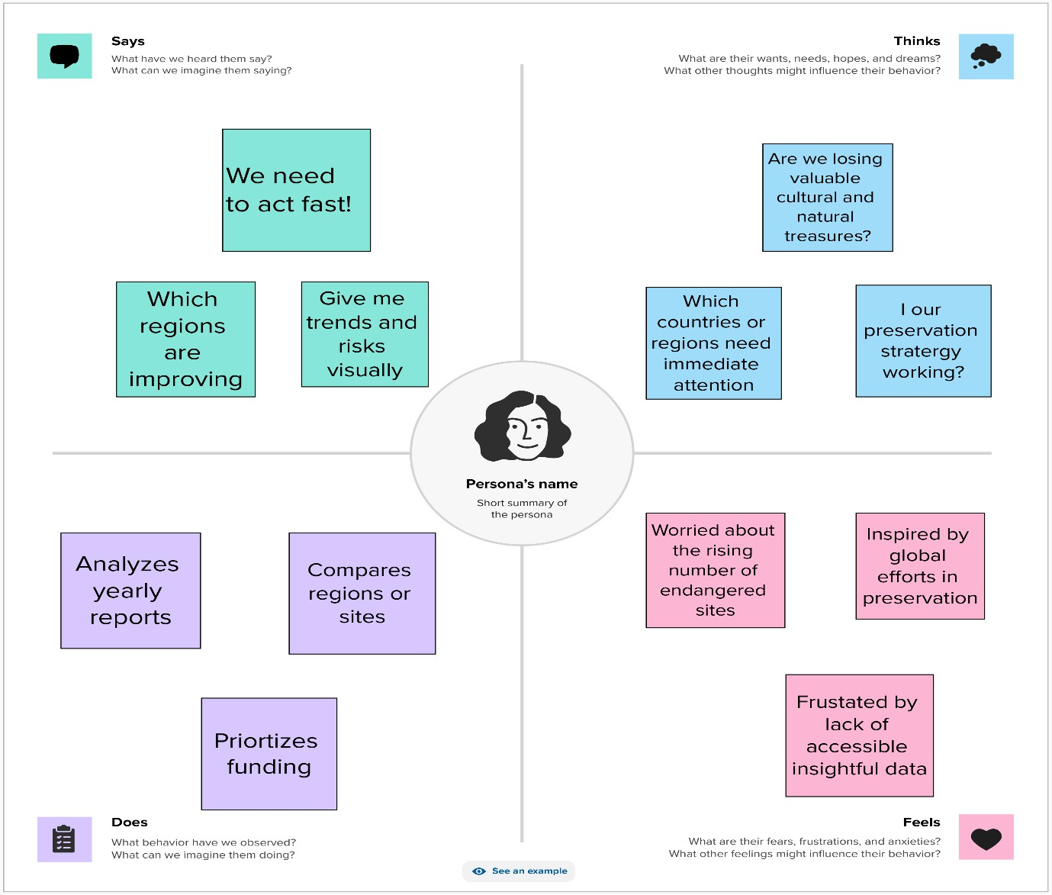

***Pain***

Limited funding without

Difficulty communic ating

Scattered or static data sources



Clear visuals to support decisions



**Gain**

Easy

storytelling with data